Primary arthrodesis in acute ligamentous lisfranc injuries
A.A.Salama, M.S.Abouzied, M.O.Hegazy
Orthopedic, Dept., Faculty of Medicine, Benha Univ., Benha, Egypt
Email: Ahmed Salama @gmail.com
Abstract
Lisfranc injuries affect the tarsometatarsal (TMT), intercuneiform, and the naviculocuneiform joints. It can be osseous, ligamentous, or a combination of the two. The major advance in the last decade has been the emphasis on early stable anatomical reduction and stabilisation of these injuries. Recent studies have suggested that primary arthrodesis may be a preferred technique for primarily ligamentous Lisfranc injuries. This study aimed to evaluate the short term results of primary arthrodesis in pure ligamentous lisfranc injuries. Twenty patients, 13 males and 7 females with a mean age of 27.4 ± 6.19 with minimum age 19 years old and maximum age 39 years old were included in this study. The most common mechanism of injury was road traffic accident (55%), followed by fall from height (40%), and followed by hyper plantar flexion foot trauma during descending stairs (5%). the mean AOFAS score of the included patients was 81.65 ± 1.60 with minimum score 80 and maximum score 84. the mean EFAS score of the included patients was 31.60 ± 1.76 with minimum score 28 and maximum score 34. the mean Pain VAS score of the included patients was 2.05 ± 0.76 with minimum score 1 and maximum score 3. the mean Union time of the included patients was 12.55 ± 0.51 weeks with minimum 12 weeks and maximum 13 weeks. In conclusion, Lisfranc injuries are complex and care must be taken in selecting the appropriate treatment. Primary arthrodesis in pure ligamentous lisfranc injury has advantages: reduced foot deformity rates, sustained biomechanical morphology of the feet, reduced complications, higher level of function recovery, shorter time of surgical procedures, fewer complications, higher AOFAS, EFAS, pain VAS scores, reduced plantar pain and decrease reoperation rates. The majority of the fusion patients had good results and osseous union.
Keyword: Arthrodesis; Lisfranc; Ligamentous; Injury

1. Introduction
Lisfranc injuries affect the tarsometatarsal (TMT), intercuneiform, and the naviculocuneiform joints. They include any combination of bony and ligamentous injury to this complex [1].
Interosseous ligaments join the bases of the second through fifth metatarsals. The Lisfranc ligament proper is a thick oblique ligament extending from the base of the second metatarsal to the plantar aspect of the medial cuneiform. The integrity of this ligament is important for stability at the TMT articulation, as there is no transverse metatarsal ligament between the first and second metatarsals as is the case between the lesser 4 metatarsals. On a cross-section, the midfoot forms a transverse plantar arch composed of asymmetrically shaped bones, with osseous and ligamentous anatomy providing a “mortise” configuration to the midfoot to support weight bearing forces. [2].
The Lisfranc ligament and its surrounding bony anatomy in the midfoot comprise a region of minimal anatomic movement in the healthy individual. The lack of motion adds rigidity to the medial and transverse arches of the foot which stabilizes the structure during activities of daily living. Injuries to the Lisfranc joint include dislocations and fractures of the bones as well as soft tissue damage. These injuries can occur in high‐energy accidents like falls from a height or low‐energy sports accidents like internal rotation while the foot is plantar flexed. Lisfranc injuries result in significant pain and discomfort for the affected individual, often developing into osteoarthritis and progressive lameness if not immediately treated. [3].
Most Lisfranc injuries are the result of an indirect mechanism of injury: 80% of patients suffer indirect injuries and 70% of those with Lisfranc fracture dislocation sustain multiple injuries or qualify as polytraumatic. When the foot is forced into maximum plantar flexion, the weaker dorsal ligaments will tear and allow dorsal dislocation and fracture of the plantar aspect of the metatarsal bases. Additional forces will shift the metatarsals on the tarsus, producing abduction and lateral displacement, with compression fractures of the tarsal bones, Chopart’s joint, and the subtalar joint [4].
Lisfranc injuries can be osseous, ligamentous, or a combination of the two. The original classification system by Quenu and Kuss described injuries as homolateral, isolated, or divergent based on the direction of the displaced metatarsals. Hardcastle et al. further categorized Lisfranc injuries into Type A, B, or C based on displacement and incongruity with a system that they thought would dictate treatment. Myerson followed with modifications to this system based on direction of dislocation despite these multiple classification schemes, outcome and treatment do not reliably correlate with any injury type [5].
Diagnosis of Lisfranc injuries is often challenging. Major fractures and dislocations are usually obvious with radiographs where the most significant findings are bone fragments and frank diastasis (separation) between the base of the second metatarsals and medial cuneiform or between the medial and intermediary cuneiform. The challenge comes from injuries without gross separations or bone fractures. These are more common in low‐energy trauma to the Lisfranc joint like those seen from sport injuries. In these cases, the soft tissues and ligaments of the midfoot are injured and result in joint instability and pain. However, 20–40% Lisfranc injuries are missed in the initial evaluation because diastasis in the joint is not easily discerned. Up to 50% of those with Lisfranc injuries will not show an opening in the Lisfranc joint unless the radiographs are taken with weight‐bearing. Even weight‐bearing radiographs have been shown to miss up to 15% of cases with Lisfranc injuries. [3].
Prompt recognition and treatment of Lisfranc injury is imperative to minimize the potential for significant long-term disability. A high index of suspicion is warranted for these injuries because they are frequently subtle or occult and can therefore be easily missed. When suspicion is present despite the absence of identifiable abnormality on plain radiograph assessment, weight-bearing radiographs and stress view examinations are recommended. General agreement exists in the literature that anatomic reduction of the Lisfranc joint is important for optimal outcome. [6].
Historically, open reduction and internal fixation was the accepted standard treatment for acute Lisfranc injuries. Fusion was primarily used as a salvage procedure in situations where patients were initially treated with internal fixation and subsequently developed post traumatic arthritis. However, more recently, primary fusion has been proposed as definitive management for those patients who have extensive articular cartilage damage that makes post traumatic arthritis inevitable. [7].
Primary fusion demonstrates superior outcomes compared to fixation when evaluating pure ligamentous or high energy Lisfranc injuries with severe joint surface damage only. Other situations where primary fusion has been recommended include patients with delayed presentations and for obese or elderly patients in whom fixation has a higher rate of failure [7].
This study aimed to evaluate the short term results of primary arthrodesis in pure ligamentous lisfranc injuries.
2. Patients and methods
This study has been conducted at the orthopedic department, faculty of medicine, Benha university hospitals on twenty patients, 13males and 7females with pure ligamentous lisfranc injuries.
2.1Inclusion criteria
To be included in the study, the patient must fulfill all the following criteria:
- Pure ligamentous lisfranc injury.
- Skeletally mature patients.
- No sex limitations.
2.2Exclusion criteria
The patients with any of the following criteria were excluded from the study:
- Inflammatory arthritis.
- Active infection.
- Severe vascular or neurological deficit affecting the lower limbs.
- Preoperative Management and Evaluation:
2.3Clinical evaluation
A detailed sheet will be taken for all patients including:
- Personal history including age, sex, occupation, special habits of medical importance.
- History of present illness, side affected, previous treatment, past history and medical co- morbidities.
2.4Present history
- Type of fracture: Pure ligamentous lisfranc injury.
- The mechanism of injury of included patients
- Special habit: 4 patients were smokers 20%, 16 patients were nonsmokers 80%.
- Medical history: 2 patients diabetic 10%, 3 hepatitis c +ve 15%, 2 patient’s hypertensive10% and 13 patient with no medical history 65%.
2.5Past history
- no previous disease or injury to affected side
- Previous operative procedure 3 patients had appendectomy 15%.
2.6clinical examination
General Examination
Pulse, blood pressure, pallor, level of consciousness..etc at the time of presentation all the patients were presented fully conscious.
B. Local Examination
Local examination of the affected side, vascular state, neurological state, skin condition, any signs of compartmental syndrome.
Side of affection:
The right side was affected in 12 (60%) patients while the left side affected in 8 (40 %) patients
Other associated injuries no patient

2.7Radiological evaluation
All patients will be examined radiologically by:
- Anteroposterior x ray of the foot.
- Oblique x ray of the foot.
- Lateral x ray of the foot with stress dorsiflexion.
- C.T. scan.
2.8Operative intervention
- The procedure will be carry out under general or regional anesthesia.
- Patient in supine position.
- We prefer the dual-incision approach.
- Primary arthrodesis of 1st, 2nd, 3rd tarsometatarsal joints.
- Back slab.
2.9Operative Technique
Positioning
The patient is placed supine with a bolster beneath the ipsilateral hip. Protective padding is placed around the contralateral limb, primarily to protect the peroneal nerve, and the contralateral limb is secured to the table.
A sterile bolster is placed beneath the operative limb at the knee to facilitate access to the midfoot and intraoperative fluoroscopy.
2.10Approach
We did single or dual-incision approach
2.11Post-operative Care
In a primary arthrodesis, the limb is immobilized in serial short-leg non-weight-bearing cast for 10 to 12 weeks after surgery, at which point radiographic union is confirmed on weight-bearing radiographs.
The patient is converted to a venous compression stocking and prefabricated fracture boot and early progression to motion is initiated.
Weight bearing is not permitted unti110 to 12 weeks postoperatively, at which point weight-bearing radiographs are obtained to confirm maintenance of reduction.
The patient is gradually allowed to resume regular shoes, and activity is advanced as tolerated thereafter.
We do not routinely remove hardware unless symptomatic or specifically requested by the patient, in which case the implants may be removed at 1 year after surgery.
Post-operative evaluation :
All patients will be followed up for at least 12 months
- AOFAS score comprises 3 areas pain function and alignment This is clinical administrated questionnaire scored out of 100
- EFAS score European foot and ankle society score out of 40
- Vas score of pain out of 10
- X-ray at each follow-up, patients were assessed with
- Anteroposterior x ray of the foot.
- Oblique x ray of the foot.
- Lateral x ray of the foot with stress dorsiflexion.
3. Results
The present study was done on 20 patients with acute ligamentous lisfranc injury who were treated operatively using primary arthrodesis.
The mean age of the included patients was 27.4 ± 6.19 years old with minimum age 19 years old and maximum age 39 years old. 4 patients were smokers 20%, 16 patients were nonsmoker’s 80%.2 patients diabetic 10%, 3 hepatitis c +ve 15%, 2 patients hypertensive10% and 13 patient with no medical history 65%.

Table (1) Demographic characteristics in study population
General characteristics
Age (years) | Mean ±SD | 27.4 ± 6.19
Gender | Male n (%) | 13 (65%)
 | Female n (%) | 7 (35 %)

The mechanism of injury of the included patients. The most common mechanism of injury was road traffic accident (55%), followed by fall from height (40%), and followed by hyper plantar flexion foot trauma during descending stairs (5%).

Table 2 Distribution of the studied group according to mechanism of injury
MECHANISM  Of injury | No | Percent
RTA | 11 | 55%
Fall from height | 8 | 40%
Hyper plantar flexion foot trauma during descending stairs | 1 | 5%

Mean AOFAS score differences according to sex shows no statistical significance between mean AOFAS regarding sex. (P value was 0.31) (P value was ˃ 0.05). Mean AOFAS score differences according to smoking shows no statistical significance between mean AOFAS regarding smoking. (P value was 0.13) (P value was ˃ 0.05). Mean AOFAS score differences according to medical history shows no statistical significance between mean AOFAS regarding medical history. (P value was 0.49) (P value was ˃ 0.05). Mean AOFAS score differences according to mechanism of injury shows no statistical significance between mean AOFAS regarding mechanism of injury. (P value was 0.24) (P value was ˃ 0.05).

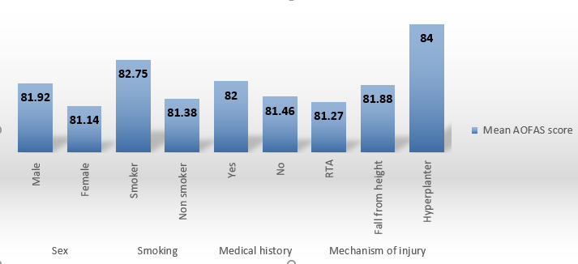
Fig 1. Mean AOFAS score differences according to sex, smoking, medical history and mechanism of injury.

Mean EFAS score differences according to sex shows no statistical significance between mean EFAS regarding sex. (P value was 0.052) (P value was ˃ 0.05). Mean EFAS score differences according to smoking shows no statistical significance between mean EFAS regarding smoking. (P value was 0.26) (P value was ˃ 0.05). Mean EFAS score differences according to medical history shows no statistical significance between mean EFAS regarding medical history. (P value was 0.64) (P value was ˃ 0.05). Mean EFAS score differences according to mechanism of injury shows no statistical significance between mean EFAS regarding mechanism of injury. (P value was 0.30) (P value was ˃ 0.05).

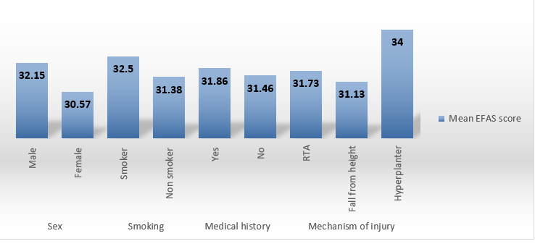
Fig 2: Mean EFAS score differences according to sex, smoking, medical history and mechanism of injury.

Mean pain VAS score differences according to sex shows no statistical significance between mean pain VAS score regarding sex. (P value was 0.70) (P value was ˃ 0.05). Mean pain VAS score differences according to smoking shows no statistical significance between mean pain VAS score regarding smoking. (P value was 0.39) (P value was ˃ 0.05). Mean pain VAS score differences according to medical history shows no statistical significance between mean pain VAS score regarding medical history. (P value was 0.15) (P value was ˃ 0.05). Mean pain VAS score differences according to mechanism of injury shows no statistical significance between mean pain VAS score regarding mechanism of injury. (P value was 0.38) (P value was ˃ 0.05)

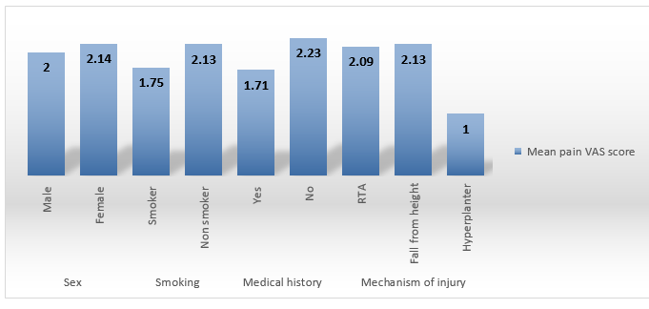
Fig 3. Mean pain VAS score differences according to sex, smoking, medical history and mechanism of injury.

Mean union time differences according to sex shows no statistical significance between mean union time regarding sex. (P value was 0.90) (P value was ˃ 0.05). Mean union time differences according to smoking shows no statistical significance between mean union time regarding smoking. (P value was 0.83) (P value was ˃ 0.05). Mean union time differences according to medical history shows no statistical significance between mean union times regarding medical history. (P value was 0.30) (P value was ˃ 0.05) Mean union time differences according to mechanism of injury shows no statistical significance between mean union times regarding mechanism of injury. (P value was 0.26) (P value was ˃ 0.05)

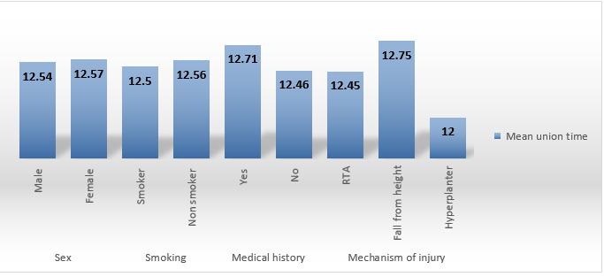
Fig 4. Mean union time differences according to sex, smoking, medical history and mechanism of injury.

Correlation between AOFAS score, EFAS score, pain VAS score and union time shows no statistical significance regarding correlation between AOFAS score (P value was 0.139) (Figure 1), EFAS score (P value was 0.542) (Figure 2), pain VAS score (P value was 0.152) (Figure 3) and union time (P value was ˃ 0.05) (Figure 4).

Table 3: Correlation between AOFAS score, EFAS score, pain VAS score and union time
 |  | Union time
AOFAS score | Pearson Correlation | -0.34
 | P value | 0.139
EFAS score | Pearson Correlation | -0.145
 | P value | 0.542
Pain VAS score | Pearson Correlation | 0.33
 | P value | 0.152

4. Discussion
The present study was a clinical study that was conducted on a consecutive 20 patients with pure ligamentous lisfranc injury who were treated operatively using primary arthrodesis at Benha university hospitals.
In the present study, the mean age of the included patients was 27.4 ± 6.19 years old and the majority of them were males (65%).
The most common mechanism of injury was road traffic accident (55%), followed by fall from height (40%), and followed by hyper plantar flexion foot trauma during descending stairs (5%).
In the present study, the mean AOFAS score of the included patients was 81.65 ± 1.60 with minimum score 80 and maximum score 84.
In concordance with our findings, SHEIBANI-RAD, Shahin, et al. revealed that the mean AOFAS score was higher in the primary arthrodesis group at 1-year follow-up for pure ligamentous and combined bony and ligamentous injuries. Also support primary arthrodesis as a primary treatment for Lisfranc joint injuries due to a significantly decreased rate of additional surgeries, as well as a tendency toward improved clinical outcome scores when compared with ORIF. [6].
Similarly, QIAO, Yusen, et al. revealed that Patients in the arthrodesis group had a higher AOFAS score compared with patients in the non-fusion group. [8].
In the present study, the mean EFAS score of the included patients was 31.60 ± 1.76 with minimum score 28 and maximum score 34.
In the present study, the mean Pain VAS score of the included patients was 2.05 ± 0.76 with minimum score 1 and maximum score 3.
In concordance with our findings, ETTINGER, Sarah, et al. revealed that TMT arthrodesis of the medial and central column resulted in significant improvement in foot function and pain. [9].
Similarly, YAN, Alan, et al. revealed that for high-energy Lisfranc injuries with obvious fracture dislocation and complete ligamentous disruption, primary arthrodesis of the medial and middle columns is preferred. [7].
In the present study, the mean Union time of the included patients was 12.55 ± 0.51 weeks with minimum 12 weeks and maximum 13 weeks.
In the present study, no statistical significance was found between mean AOFAS regarding sex (P value was 0.31), smoking (P value was 0.13), medical history (P value was 0.49) and mechanism of injury (P value was 0.24) (P value was ˃ 0.05).
In the present study, no statistical significance was found between mean EFAS regarding sex. (P value was 0.052), smoking (P value was 0.26), medical history (P value was 0.64) and mechanism of injury (P value was 0.30) (P value was ˃ 0.05).
In the present study, no statistical significance was found between mean pain VAS score regarding sex (P value was 0.70), smoking (P value was 0.39), medical history (P value was 0.15) and mechanism of injury. (P value was 0.38) (P value was ˃ 0.05).
In the present study, shows no statistical significance was found between mean union times regarding sex (P value was 0.90), smoking (P value was 0.83), medical history (P value was 0.30) and mechanism of injury (P value was 0.26) (P value was ˃ 0.05).
In the present study, shows no statistical significance regarding correlation between AOFAS score (P value was 0.139), EFAS score (P value was 0.542) and pain VAS score (P value was 0.152) and union time. (P value was ˃ 0.05)
5. Conclusion
Lisfranc injuries are complex and care must be taken in selecting the appropriate treatment. Primary arthrodesis in pure ligamentous lisfranc injury has advantages: reduced foot deformity rates, sustained biomechanical morphology of the feet, reduced complications, higher level of function recovery, shorter time of surgical procedures, fewer complications, higher AOFAS, EFAS, pain VAS scores, reduced plantar pain and decrease reoperation rates. The majority of the fusion patients had good results and osseous union.
According to our research, primary arthrodesis may be a better choice for treating pure ligamentous Lisfranc injury.
6. References
[1] N.Smith , C.Stone , A.Furey . Does open reduction and internal fixation versus primary arthrodesis improve patient outcomes for Lisfranc trauma? A systematic review and meta-analysis. Clinical Orthopaedics and Related Research®. Jun.vol. 1;474(6),pp.1445-52,2016.
[2] J. Lewis , R. Anderson . Lisfranc injuries in the athlete. Foot & Ankle International. Dec.vol.37(12),pp.1374-80,2016.
[3] J.OWEN. Computational Analysis of the Clinical Presentation of a Ligamentous Lisfranc Injury. Journal of Orthopaedic Research: Official Publication of the Orthopaedic Research Society.vol.8,pp.22-33,2021.‏
[4] J.van Rijn , D.Dorleijn , B.Boetes, Wiersma-Tuinstra , S.Moonen. Missing the Lisfranc fracture: a case report and review of the literature. The Journal of foot and ankle surgery. Ma.vol.r 1;51(2),pp.270-4,2012.
[5] T.Schepers , P.Oprel , E.Van Lieshout . Influence of approach and implant on reduction accuracy and stability in Lisfranc fracture-dislocation at the tarsometatarsal joint. Foot & ankle international. May.vol.34(5),pp.705-10,2013.
[6] RSHEIBANI And Shahin . Arthrodesis versus ORIF for Lisfranc fractures. Orthopedics.vol.35.6,pp. e868-e873,2012.
[7] YAN And Alan . Updates on Lisfranc Complex Injuries. Foot & Ankle Orthopaedics.vol. 6.1,pp. 2473011420982275, 2021.
[8] QIAO And Yu‐sen . Comparison of Arthrodesis and Non‐fusion to Treat Lisfranc Injuries. Orthopaedic surgery.vol. 9.1,pp. 62-68,2017.
[9] ETTINGER And Sarah. Comparison of Isolated Screw to Plate and Screw Fixation for Tarsometatarsal Arthrodesis Including Clinical Outcome Predictors. Foot & Ankle International.vol.8,pp.1071100720980014,2021.

